
From the Principal’s Desk
Welcome to Week 6! Our first 5 weeks have been action packed and have literally flown by. The rest of the term doesn’t look like slowing down so I urge parents to keep up to date by using our live calendar which can be found on our website.

If you haven’t had a chance yet make sure you walk through the front reception and see the wonderful art work on display. Suzi Bird, an artist from our parent community and the Year 1 students have created a stunning piece of art that celebrates cultural diversity. It is titled ‘It takes all kinds of fish to make a school’. It certainly brings to the forefront the importance of encouraging everyone to experience, explore and appreciate WA's wealth of cultural, religious, linguistic and ethnic diversity. As a school we will be celebrating this diversity on March 21 as part of Harmony Day 2018. The theme this year is ‘everyone belongs’ which is something the Lakelands community does very well.

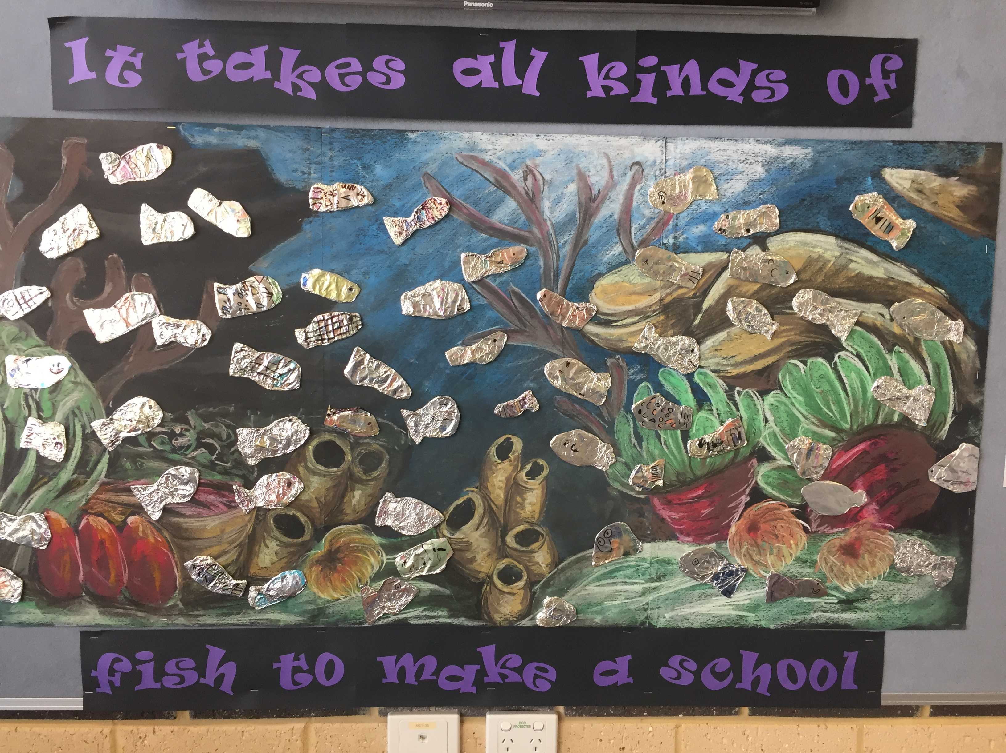

I met with the P&C recently and they have some great activities planned this term. It is a real pleasure to be part of such an enthusiastic team whose main focus is raising money for much needed resources. This year they are raising money for a new playground for the junior students. Think climbing frames, climbing ropes, slides, platforms linking bridges and soft fall surfaces. The possibilities are endless! The good news is we get to design the playground to suit our students. I invite parents to get on board and lend a hand as we all know the old saying ‘many hands make light work’! The P&C will be meeting again on Wednesday 14 March at 8.45am in the staff room. I hope to see you there.
Don’t forget you can always stay up to date with all the latest information and events via our website Lakelands.PS@education.wa.edu.au, MessageU and the P&C Facebook site – Lakelands PS Information and Events.

Student Councillors
I was very privileged to be part of the Student Council nomination process a few weeks ago. We had a record number of students vying for position and some very impressive speeches. Whilst we introduced our councillors at the assembly last week it gives me great pleasure to announce Aimee, Angelina, Harri, Luke, Mason and Tayah as our Student Council for 2018. Congratulations! They have made an excellent start to their role by assisting Mrs Muir last week during our school photos. I look forward to chatting to them all at our first Admin Meeting this week.

Faction Captains
The faction caption elections are now completed. We congratulate the students below who will be a great help to Mrs De Oliveira this year.

Gold: Jonty (5.10) and Ava (5.10)
Red: Casey (4.2) and Mia (4.1)
Green: Cade (4.2) and Mikayla (4.1)
Blue: Callum (4.1) and Tarni (5.10).

Parent Interviews
As a part of our reporting policy we are holding parent interviews in Week 9, 10 and 11 of this term (March 26 – April 13). The purpose of the interview is to provide the opportunity for parents to meet with the teacher to discuss their child’s progress. Interviews will be scheduled in 20 minutes time slots either throughout the day or after school. We strongly encourage parents to book an interview time. Details on booking interviews will be sent home over the coming weeks.

Swimming Lessons
Our Year 4 to 6 students will be involved in swimming lessons at Doddi’s Beach in weeks 10 and 11 of this term. Our lifestyle is based around beaches and open water and it is for this reason that the lessons are held at the beach for our older students. Letters were sent out last week asking parents to forward payment as well as the information regarding your child’s swimming ability. It is vital we receive this information back by March 21 so we can ensure your child is placed into the correct swimming group. If you require further information please don’t hesitate in contacting our office on 9584 2601. Parents please note that our Pre-Primary to Year 3 students still do their lessons at the Mandurah Aquatic Centre and that will occur in Term 2.

Ride2School Day
Friday 23rd March 2018 marks the eleventh National Ride2School Day, where over 250,000 Australian children will ride and walk to school. It is a day that celebrates riding and walking and encourages everyone to give it a go!

At Lakelands Primary School, we support Active Transport, which includes riding, walking, scooting or skating to school. To help celebrate this day we will be holding a dress up your bike day. Students are encouraged to dress up their bikes and ride to school on this day. A prize will be awarded to the student with the best dressed bike from the following: K & PP, Years 1,2 & 3 and Years 4,5 & 6.

Voluntary Contributions Update
Thank you to the parents who have been in recently to pay their Voluntary Contributions. In the last newsletter we had 4.1% of parents paid. Now we have 19.38%. Remember this contributes to the purchase of additional resources and the running of programs in the school which have a direct impact on your children’s learning. Every cent of the contributions you make is spent directly on our students.

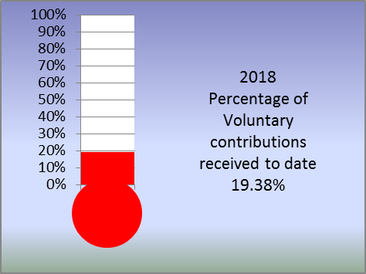
Last year only 33% of parents paid. We need your help to move the thermometer up and reach our goal of 75% of parents paid.

Account Name: Lakelands Primary School

BSB: 016 745
A/C Number: 190756561

Please ensure you include student name and reason for payment.

Regards

Marnie Hamilton
Principal
Lakelands Primary School

Science Club with Mrs Theodosiou and Mrs Starbuck
Science Club is up and running again this year. We have created fake snow and made sherbet, explored the Nature Garden, fed our crunch and sip scraps to the worms, constructed models and more. We have Science club on Mondays, Wednesdays (Worm Warriors), Thursdays and Fridays with Mrs Starbuck or Mrs Theo.

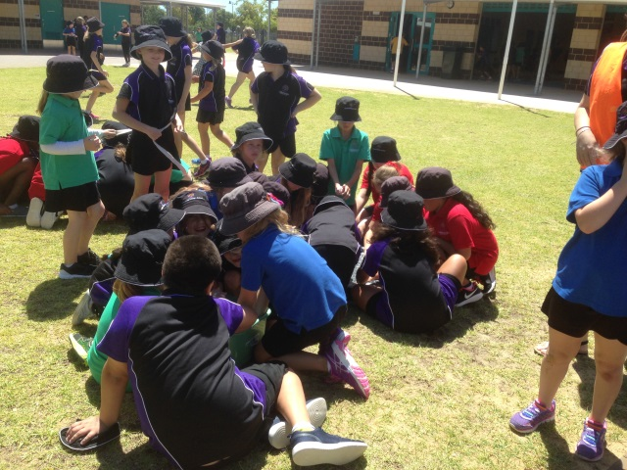

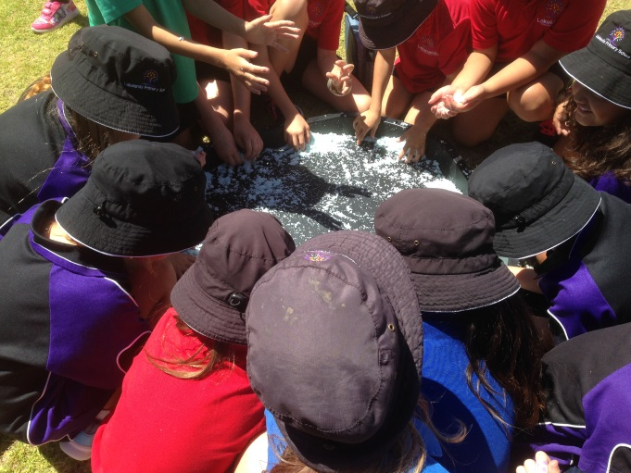

High School Update – Message from the new principal, Kya Graves
I am seeking expressions of interest from parents and potentially some community representatives to form a Steering Committee. The role of the Steering Committee includes:
• Providing a sounding board for the Principal on specific issues e.g. IPS status; school name; logo, colours and uniform; school brand, motto and values; and community expectations.
• Provide support to the Principal in preparing the school for opening e.g. community communication; initiatives and expertise.

The Steering Committee is separate to the School Board as the roles are different and a School Board will not commence until the start of 2019.

I am seeking people with a broad and representative perspective. Therefore people who may apply for future positions in the school, government representatives or people with vested interests may not be the best fit. A good size would be 12-15 people so if more people apply than there are places, then selections may be necessary on the basis of ensuring balanced representation.
If you wish to submit an expression of interest please email me using
Lakelands.SS@education.wa.edu.au including your contact details, and if appropriate which school your children currently attend.

Attending School Matters…
At Lakelands Primary School we want your children to do their very best. To get the best education they need to attend school every day.
1 or 2 days doesn’t seem like much but…
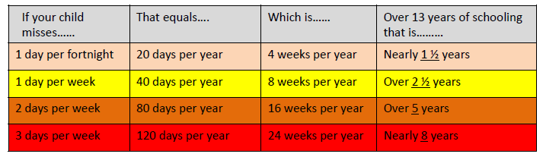

At school, many concepts such as literacy and numeracy are taught in a sequence. Missing school means missing out on learning – which can often make it difficult to catch up later. This is particularly important in the early years when essential foundation skills are being taught.
Going to school every day helps children learn the important life skill of ‘showing up’ – at school, at work, to sport and other commitments.
Harmony Day
Harmony Day celebrates Australia’s cultural diversity. It’s about inclusiveness, respect and a sense of belonging for everyone.

Harmony Day will be celebrated on Wednesday 21 March. Our assembly for Harmony Day will include a student dress up with the theme of traditional cultural dress; we invite all families from Pre-primary to Year 6 to join us for our Harmony Day assembly at the earlier time of 8:40am, where students will parade their outfits. A note will be sent home with further information about the student dress up theme.

Canteen News
Crunch & Sip is available for purchase; we have watermelon cups or apples, plus bottled water.
Paddle Pops $2 and Zooper Doopers $1 available daily at lunchtime.

Did you know our slushies are 98% pear juice and have all natural colours and flavours? Only $2.
We have a variety of options for recess every day, plus
a daily special for recess.

I would like to encourage you to use our online ordering system. You can do it from the comfort of your own home, and can order in advance. Once your account is set up, you can top up money any time and order when it suits you.

We offer $20 canteen vouchers so you can leave them in the canteen and use it like a credit system. It will save you and your kids carrying money to school. You will have an extra $1 to spend with this option.
Eftpos is available any time, minimum spend is $10.

Kelly
LLPS Canteen

Dress Ups Needed
We are seeking donations of dress ups for our junior play area. Please see Rachel Hassett in 1.4 if you have any you would like to donate.
Thank you

From our Nurse
Welcome to the new school year. My name is Philippa Sgro and I am the Community Health Nurse who visits your school.
Community Health Nurses work in schools to promote healthy development and wellbeing so students may reach their full potential. A major part of my work is focused on early intervention and the School Entry Health Assessment program.
Community Health Nurses serve as a health contact point for children and their families, providing information, assessment, health counselling and referral. The services provided are free and confidential.
If you have a concern about your child’s health or development, please contact me on 0406 303 709

P&C News

Week 6 already! We had our first meeting; thank you to everyone who attended, it was great to see so many new faces. We worked out a schedule of fundraising events for the year with some of the fun ideas from last year but also some very exciting new ideas! We also had a guest speaker, Kya Graves, the principal of the new high school under construction in Lakelands. It was great to hear some of the details about the new school. If anyone is interested in being on the team please either join us at our next meeting or email your interest to lakelandspspc@outlook.com. Stay in touch with all school and P&C news by joining our Facebook page https://www.facebook.com/groups/1477892799091841/

Scholastic
Thank you to everyone who placed an order. Your books should arrive in the next week or two.
Coles Token Challenge 2017
Firstly we would like to thank everyone who contributed to the Coles token challenge at the end of last year. We came second to Meadow Springs PS and Secret Harbour Life Saving Club came third. We won $600 for second place so again thank you to everyone who supported.
Letter Drop
We have a letter drop coming up for an event run by Creating Communities. At this stage it looks like this will take place on the weekend so if you are keen to help out please contact Kristen Morris at russten2@bigpond.com
Easter Raffle
This was a huge hit last year! Tickets will be only 50c or you can donate a chocolate egg/bunny and receive 2 tickets into the raffle. There will be a basket at the office for chocolate collection from the 12 March and the raffle will be drawn on the 28 March. A flyer will be going home with more details. Good luck!
School Banking
School banking is on each Thursday morning before school in the undercover area. There are no fee's involved. It is a great way to teach your children about money and saving. When your child makes 10 deposits (which could be as little as 50 cents each time) your child will receive a prize. If you would like to participate, application packs can be found at the front office or sign up for a youth savers account at your local commonwealth bank branch. Any enquiries please contact Kimberley Bebbington at kim@bebbington.com.au
Discount Card
For only $10 you can save $100s by purchasing the 2018 Lakelands Primary School Discount Card. There are currently 55 local businesses offering discounts to card holders. There is something for everyone including dining, health and fitness, pet care, cosmetics, trades, etc. It is great value and is available to everyone so be sure to tell your family, friends and neighbours. Cards can be purchased from the front office at school.

Coles Sports for School
Collect 1 voucher for every $10 spent at Coles and help us get some great new sports gear for the school. Don't forget to ask for your coupons at the checkout. You can put the coupons in the box at Coles (located near the service desk) or place them in the P&C box at the school office. This promotion finishes on the 3 April. Big shout out to Kristen Morris for volunteering to count the coupons! The total after week 2 is 7450!
Disco
The popular disco is back! It is all booked in for the 23 March, Junior 3:45pm-5pm and Senior 5:15pm-7pm. There will be a flyer sent home soon with more details. We are always looking for volunteers so if you are free, fill out the flyer and return to the P&C box or email me anytime Megancleary2018@hotmail.com. There is also another section on the form with student details - this MUST be handed in when paying for entry on the night for EVERY student.
TERM 1 Events For Your Calendar

Easter Raffle | Commencing 12 March
Disco | 23 March
Carpark raffle | commencing 4 April
Free Dress Day/sausage sizzle | 13 April
Meeting | 14 March, 8.45am
Megan Cleary
Megancleary2018@hotmail.com

Community News



