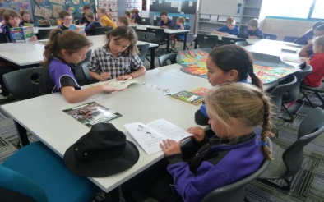

Good Standing Policy

The Lakelands Primary School Good Standing Policy has been established to allow for the development and nurturing of all students. A framework is provided around which students will be able to develop skills that contribute to them becoming lifelong learners.
Good Standing is a status all Lakelands students are granted at the beginning of each term.
Students with Good Standing are eligible to participate in a whole school reward at the end of each term.
It is the responsibility of each student to maintain their Good Standing

To maintain Good Standing students must:
- Comply with school rules
- Comply with individual classroom rules

A student’s Good Standing status will be withdrawn following consultation with the administration and the classroom teacher for:
Three times to Buddy Class (Think Sheet completed)
OR
Three times to the office (Stage 3 and/or fast tracked)
OR
One suspension

Students who lose their Good Standing status will lose the right to participate in whole school rewards for that term.

Good Standing is restored at the beginning of each term.

